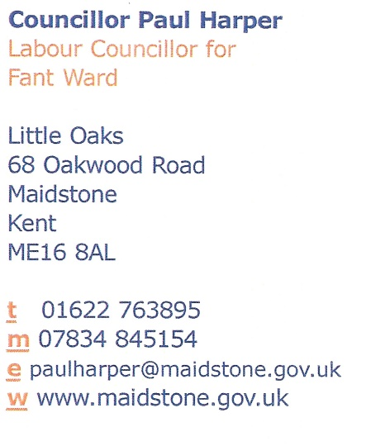1st April 2021 – UPPER FANT ROAD MAST Rejected



**GREAT NEWS UPPER FANT ROAD MAST TURNED DOWN**

Dear Resident,

As I said when speaking to you over the last few days, I have managed to check and the Mast application has been refused.

This is excellent news and shows that when working with the community the Fant and Bower Group, Residents and Councillors can stop corporate business wrecking our neighbourhood.

Details of the rejection of the proposal can be found at the following web address:

[21_500446_TNOT56-Delegated_Report_MBC-5203745.pdf (midkent.gov.uk)](https://pa.midkent.gov.uk/online-applications/files/3CEAFD7DF413C5042E33CFDB51DB6D63/pdf/21_500446_TNOT56-Delegated_Report_MBC-5203745.pdf)

This has been achieved against the odds as it is very unusual for such applications to be turned down.

I would like to say a great thank you on behalf of Fant residents to all those who took the time to send in their objections.

Once the elections are out of the way, working with your other Labour Councillors I will look again into our application for a 20mph zone across Fant. As I have said to a number of you already we will also as a

standby investigate other alternatives to slow the traffic in the road and look at rat running, including trying to get Kent County Council to address the issue and consider traffic calming measures.

As the drop in sessions are cancelled residents can contact us by email, phone or via [www.maidstonelabour.com/get-in-touch/](http://www.maidstonelabour.com/get-in-touch/)” Cllr Paul Harper says “I have missed the opportunity to speak with you over the last year during the pandemic, but to keep in touch our regular newsletters are now being published on our website at https://www.maidstonelabour.com/category/fant-labour-news/ please go there to see what we are doing and to keep up to date with Fant news and also https://www.maidstonelabour.com/category/fant-councillors-blog/ to see our regular blogs.

**Please Support Patrick Coates**

Finally so that you local Councillors can continue to support you, can I ask for you to please vote for Patrick Coates to be you new Labour Councillor on the 6th May 2021. Only by having 3 Labour Councillors for Fant can we continue to ensure that the needs of the Fant Community get listened to at Maidstone Council.

Yours sincerely

Paul Harper

|  |  |  |
| --- | --- | --- |
|  | ON YOUR SIDE IN FANT  www.maidstonelabour.com | Hotline 07834 845154 |

Published and Printed by Maidstone and Weald Labour Party, 68 Oakwood Road, ME16 8AL